Lab-1
E-learning platforms fail to keep learners engaged
Name: Nivedh Sunil Roll No.: 24BTCE111
Key Observations
- Lack of proper UI/UX designs.
- Most of the learning contents are long videos and presentations which lack in interactivity to keep the learning platform engaging.
- Few platforms are text-heavy, making it less engaging and people start to divert from the platform.
- Lack of user specific content leading to incompletion rates and frustration.

Stakeholder identification
- Students: Active Participants, managing their own learning through self-paced navigation, discussions and assignments
- Instructors: Instructors design courses, facilitate discussions, provide timely feedback, and monitor progress to foster community and accountability.
- corporate learners: business-relevant modules with simulations, flexible scheduling, measurable outcomes and integration
Interview questionnaire & responses
- How does poor UI/UX impact your platform use?
- What frustrates you about long videos lacking interactivity?
- Why do text-heavy formats cause disengagement?
- How does content uniformity lead to incompletion?
- Name one interactive feature to boost engagement.
- Rate need for diverse content (short modules/visuals): 1-10.
- How does confusing navigation reduce your session time?
- Why do dense text blocks prompt you to quit?
- How does repetitive content format cause frustration?
- What do you do when there are long texts in the courses you do.
- Suggest a self-paced learning improvement.
- What flexible design fixes dropout risks?
Key Insights from the interview:
The survey data, was filled mostly by from Students (Age 18-24). It was revealed that a high demand for diverse, interactive content, with requests for gamification, simulations and quizzes. The core problem noticed in the survey was text overload, which prompts users to actively avoid content by skipping or using AI tools to summarize, leading to incomplete learning.
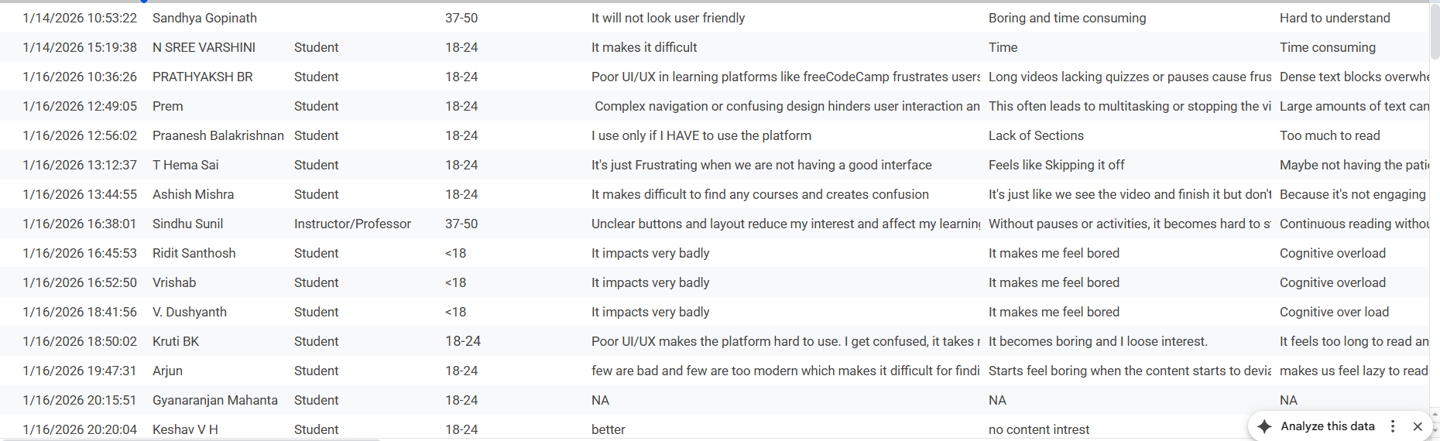
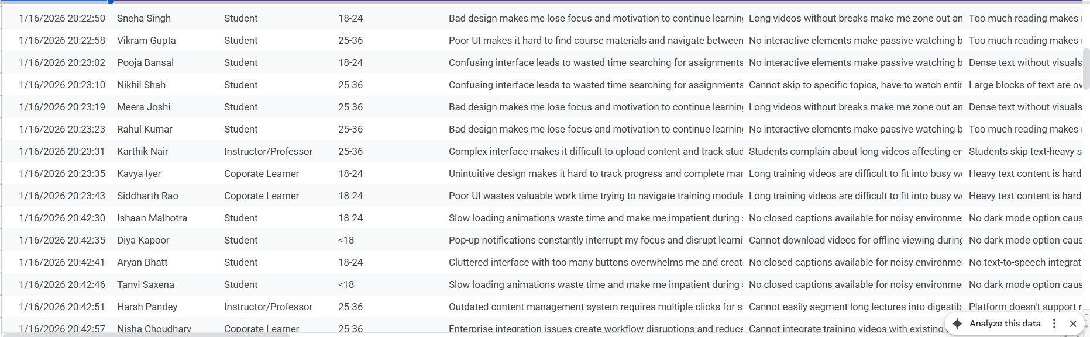
Pain-point analysis table
Category | Identified Pain Points
Functional | Confusing navigation/UI design leading to wasted time searching.
Emotional | Content uniformity and text heavy content leads to boredom, causing a critical lack of motivation and resulting in user frustration and dropouts.
Systemic | The absence of accessibility features, such as Improper Navigation Design, Dark Mode and Captions, creates discomfort and limits use for some learners.
Critical Pain Point:
High risk of disengagement and course incompletion was caused by text-heavy content and long videos, which actively prompt users to skip key sections or abandon the course entirely.
Root cause Identification
- 1st Why: Why do users disengage and not complete the courses?
  - Because the content is monotonous, text-heavy and unengaging (like dense text blocks, long passive videos and repetitive structures).
- 2nd Why: Why is the content monotonous and unengaging?
  - Because the content creation process relies heavily on a uniform format that lacks variety, interactivity and visual/cognitive breaks.
- 3rd Why: Why does the content creation rely on a uniform format?
  - Because the content creators are not equipped to produce diverse, modular and interactive learning elements (like simulations, quick quizzes, gamification).
- 4th Why: Why are content creators not producing diverse, interactive elements?
  - Because there is a lack of systemic platform features and builder tools to easily implement and manage these advanced learning elements.
- 5th Why (Root Cause): Why is there a lack of systemic platform features for advanced learning?
  - The platform's foundational architecture and resource allocation have historically prioritized basic content delivery (like storage, streaming) over modern, interactive learning pedagogy and functional design.
Wicked problem explanation
The “Scale and Engagement in course design” is found to be the Wicked problem in the survey.
- Users want more engagement, but platforms focus on scalable and uniform content.
- Simple fixes do not work, while complex ones cost a lot and fit only specific cases.
- This problem links user psychology with the lack of tools for creators.
- "Engagement" is a challenge that needs constant changes and full-time effort.
The problem is found to be wicked.
Reflection
- Lack of proper UI/UX designs.
  - The assumption regarding the hinderance of platform use due to poor UI/UX was found to be true as the survey responses explicitly mentioned "confusion in navigation" and that it "hinders user interaction and exploration," leading to users feeling lost and exiting sessions prematurely.
- Most of the learning contents are long videos and presentations which lack in interactivity to keep the learning platform engaging.
  - The assumption that long videos lacking interactivity are unengaging was found to be true as the survey revealed users find these videos "Boring and time consuming" leading to "mind-wandering and poor retention" and this was directly supported by the strong user request for Quizzes/Quick Assessments as the most-needed interactive feature.
- Few platforms are text-heavy, making it less engaging and people start to divert from the platform.
  - The assumption that text-heavy formats cause disengagement was found to be true because users reported experiencing "cognitive overload" and admitted to actively avoiding the content by skipping sections or using AI tools like ChatGPT to summarize the dense text, which is a direct sign of diversion.
- Lack of user specific content leading to incompletion rates and frustration.
  - The assumption that content uniformity leads to incompletion was found to be true and was the most quantifiable validation, with the need for diverse content (short modules/visuals) rated extremely high, proving that the uniform format is undesirable and contributes to feelings of "lack of interest." All four initial assumptions underlying the survey were thus found to be true as validated by the responses.

